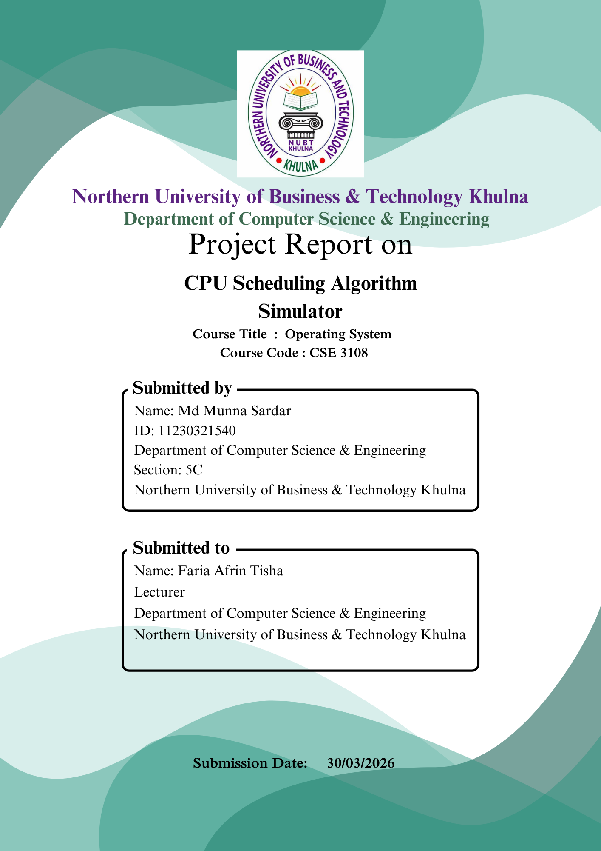

Table of Contents
1. Introduction 3
2. Formulas Used (Applicable to All Algorithms) 3
3.FCFS (First Come First Served) 4
4.SJF (Shortest Job First - Non-Preemptive) 10
5.Round Robin (RR) 15
6. Conclusion 23

CPU Scheduling Algorithm Simulator
(FCFS, SJF Non-Preemptive, Round Robin)

1. Introduction
CPU scheduling is one of the most important responsibilities of an operating system. It determines which process will be executed by the CPU at a given time. Efficient scheduling improves system performance by reducing waiting time and maximizing CPU utilization.
In this project, three CPU scheduling algorithms are implemented:
- First Come First Served (FCFS)
- Shortest Job First (SJF – Non-Preemptive)
- Round Robin (RR)
Each algorithm takes processes as input with Arrival Time (AT) and Burst Time (BT), executes them based on its own logic, and calculates performance metrics.

2. Formulas Used (Applicable to All Algorithms)
The following formulas are used in all three scheduling algorithms:

Completion Time (CT)
Time at which a process completes execution.

Turnaround Time (TAT):
$$TAT=CT-AT$$

Waiting Time (WT):
$$WT=TAT-BT$$

Where:
- AT = Arrival Time
- BT = Burst Time

3.FCFS (First Come First Served)

1. Abstract
First Come First Served (FCFS) is the simplest CPU scheduling algorithm where processes are executed in the order of their arrival. This part of the project demonstrates how FCFS schedules processes without preemption and evaluates system performance using Completion Time, Turnaround Time, and Waiting Time.

2. Objective
- To implement FCFS scheduling algorithm
- To simulate execution order based on arrival time
- To calculate CT, TAT, WT
- To analyze its performance
3. Theory
FCFS is a non-preemptive scheduling algorithm. Processes are placed in a queue and executed one by one in arrival order. Once a process starts execution, it runs until completion.
4.Code:

#include <iostream>
#include <vector>
#include <algorithm>
using namespace std;

struct Process {
string pid;
int at, bt, ct, wt, tat;
};

int main() {
int n;
cout << "Enter number of processes: ";
cin >> n;

vector<Process> p(n);

for (int i = 0; i < n; i++) {
p[i].pid = "P" + to_string(i + 1);
cout << "Arrival Time for " << p[i].pid << ": ";
cin >> p[i].at;
cout << "Burst Time for " << p[i].pid << ": ";
cin >> p[i].bt;
}

sort(p.begin(), p.end(), [](Process a, Process b) {
return a.at < b.at;
});

int time = 0;
vector<int> timeline;

for (int i = 0; i < n; i++) {
if (time < p[i].at)
time = p[i].at;

timeline.push_back(time);

time += p[i].bt;

p[i].ct = time;
p[i].tat = p[i].ct - p[i].at;
p[i].wt = p[i].tat - p[i].bt;
}

timeline.push_back(time);

cout << "\nGantt Chart:\n";

for (int i = 0; i < n; i++) {
cout << "--------";
}
cout << "-\n";

for (int i = 0; i < n; i++) {
cout << "| " << p[i].pid << " ";
}
cout << "|\n";

for (int i = 0; i < n; i++) {
cout << "--------";
}
cout << "-\n";

for (int i = 0; i <= n; i++) {
cout << timeline[i] << "\t";
}
cout << endl;

float total_wt = 0, total_tat = 0;

cout << "\nPID\tAT\tBT\tCT\tTAT\tWT\n";
cout << "----------------------------------------\n";

for (auto proc : p) {
cout << proc.pid << "\t"
<< proc.at << "\t"
<< proc.bt << "\t"
<< proc.ct << "\t"
<< proc.tat << "\t"
<< proc.wt << endl;

total_wt += proc.wt;
total_tat += proc.tat;
}

cout << "\nAverage WT: " << total_wt / n;
cout << "\nAverage TAT: " << total_tat / n << endl;

return 0;
}

4.1 Output Screenshot:
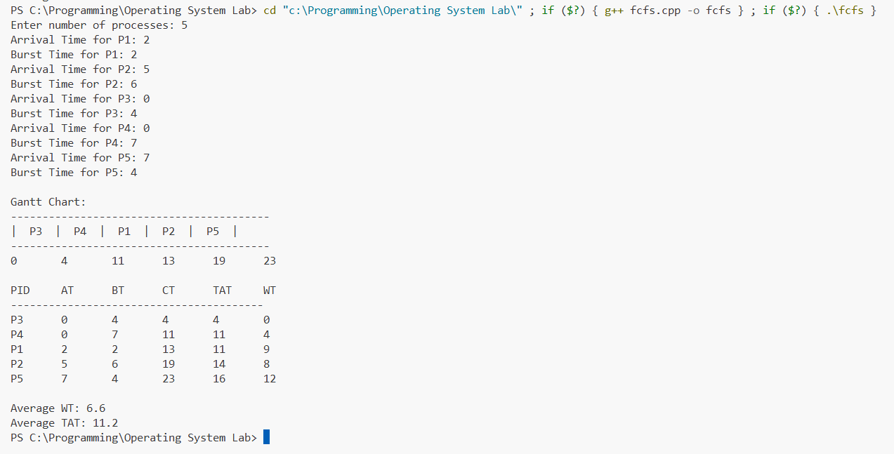

5. Code Explanation (FCFS CPU Scheduling)
5.1 Header Files
#include <iostream>
#include <vector>
#include <algorithm>
Explanation:
- iostream → input/output operations
- vector → store process information
- algorithm → used for sorting processes by arrival time

5.2 Process Structure
struct Process {
string pid;
int at, bt, ct, wt, tat;
};
Explanation:
This structure stores all required process details:
- pid → Process ID
- at → Arrival Time
- bt → Burst Time
- ct → Completion Time
- tat → Turnaround Time
- wt → Waiting Time

5.3 Input Section
for (int i = 0; i < n; i++) {
p[i].pid = "P" + to_string(i + 1);
cin >> p[i].at >> p[i].bt;
}
Explanation:
- Takes arrival time and burst time for each process
- Automatically assigns process IDs (P1, P2, etc.)

5.4 Sorting by Arrival Time
sort(p.begin(), p.end(), [](Process a, Process b) {
return a.at < b.at;
});
Explanation:
- Processes are sorted based on arrival time
- Ensures First Come First Serve order
5.5 CPU Execution Logic
if (time < p[i].at)
time = p[i].at;

time += p[i].bt;
Explanation:
- If CPU is idle, jump to process arrival time
- Process executes fully (no preemption in FCFS)
5.6 Completion, TAT, WT Calculation
p[i].ct = time;
p[i].tat = p[i].ct - p[i].at;
p[i].wt = p[i].tat - p[i].bt;
Explanation:
- Completion Time = when process finishes execution
- Turnaround Time = CT − AT
- Waiting Time = TAT − BT

5.7 Gantt Chart Construction
timeline.push_back(time);
Explanation:
- Stores execution timeline points
- Used to display Gantt chart

5.8 Gantt Chart Display
for (int i = 0; i < n; i++) {
cout << "| " << p[i].pid << " ";
}
Explanation:
- Shows execution order of processes in FCFS manner

5.9 Time Line Display
for (int i = 0; i <= n; i++) {
cout << timeline[i] << "\t";
}
Explanation:
- Displays start and end time of each process execution

5.10 Average Time Calculation
total_wt += proc.wt;
total_tat += proc.tat;

cout << total_wt / n;
cout << total_tat / n;
Explanation:
- Computes average Waiting Time
- Computes average Turnaround Time

7. Discussion
- Simple and easy to implement
- Causes long waiting time if long job comes first
- Not suitable for interactive systems

4.SJF (Shortest Job First - Non-Preemptive)
1. Abstract
Shortest Job First (SJF) selects the process with the smallest burst time among available processes. This part of the project shows how SJF improves efficiency by minimizing average waiting time.

2. Objective
- To implement SJF scheduling
- To reduce average waiting time
- To compare performance with FCFS

3. Theory
SJF is a non-preemptive scheduling algorithm. At each step, the process with the shortest burst time is selected from the ready queue.

4.Code:
#include <iostream>
#include <vector>
using namespace std;

struct Process {
string pid;
int at, bt, ct, wt, tat;
bool done = false;
};

int main() {
int n;
cout << "Enter number of processes: ";
cin >> n;

vector<Process> p(n);
//for input
for (int i = 0; i < n; i++) {
p[i].pid = "P" + to_string(i + 1);
cout << "Arrival Time for " << p[i].pid << ": ";
cin >> p[i].at;
cout << "Burst Time for " << p[i].pid << ": ";
cin >> p[i].bt;
}
int time = 0, completed = 0;
vector<string> order;
vector<int> timeline;
//here start excution sjf
while (completed < n) {

int idx = -1;
int minBT = 1e9;

for (int i = 0; i < n; i++) {
if (p[i].at <= time && !p[i].done && p[i].bt < minBT) {
minBT = p[i].bt;
idx = i;
} }
if (idx == -1) {
time++;
continue;
}
order.push_back(p[idx].pid);
timeline.push_back(time);

time += p[idx].bt;

p[idx].ct = time;
p[idx].tat = p[idx].ct - p[idx].at;
p[idx].wt = p[idx].tat - p[idx].bt;

p[idx].done = true;
completed++;
}
timeline.push_back(time);
//gantt chart table
cout << "\nGantt Chart:\n\n";

for (int i = 0; i < n; i++) cout << "--------";
cout << "-\n";

for (string x : order) {
cout << "| " << x << " ";
}
cout << "|\n";

for (int i = 0; i < n; i++) cout << "--------";
cout << "-\n";

for (int i = 0; i < timeline.size(); i++) {
cout << timeline[i] << " ";
}
cout << "\n";
// this table after excution
float totalWT = 0, totalTAT = 0;

cout << "\nPID\tAT\tBT\tCT\tTAT\tWT\n";
cout << "--------------------------------\n";

for (auto &x : p) {
cout << x.pid << "\t"
<< x.at << "\t"
<< x.bt << "\t"
<< x.ct << "\t"
<< x.tat << "\t"
<< x.wt << "\n";

totalWT += x.wt;
totalTAT += x.tat;
}

cout << "\nAverage WT: " << totalWT / n;
cout << "\nAverage TAT: " << totalTAT / n << endl;
return 0;
}
4.1. Output
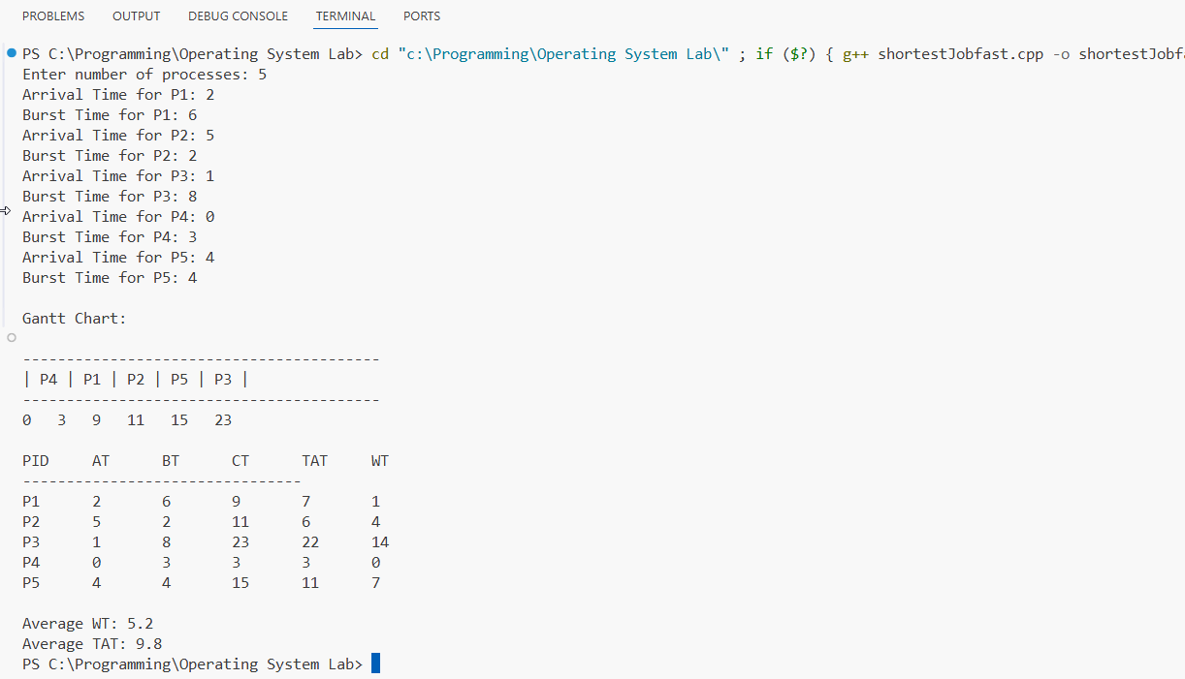

5. Code Explanation (SJF CU Scheduling)

5.1 Process Structure
struct Process {
string pid;
int at, bt, ct, wt, tat;
bool done = false;
};
Explanation:
Stores process information:
- at → Arrival Time
- bt → Burst Time
- ct → Completion Time
- wt → Waiting Time
- tat → Turnaround Time
- done → marks completion
5.2 Selecting Shortest Job
int idx = -1;
int minBT = 1e9;
Explanation:
- idx → stores selected process
- minBT → stores smallest burst time

5.3 Finding SJF Process
for (int i = 0; i < n; i++) {
if (p[i].at <= time && !p[i].done && p[i].bt < minBT) {
minBT = p[i].bt;
idx = i;
}
}
Explanation:
Selects process with:
- arrived already
- not completed
- smallest burst time
5.4 CPU Idle Handling
if (idx == -1) {
time++;
continue;
}
Explanation:
- If no process available, CPU waits

5.5 Process Execution
time += p[idx].bt;
Explanation:
- Process runs completely (Non-preemptive SJF)

5.6 Completion Time Calculation
p[idx].ct = time;
p[idx].tat = p[idx].ct - p[idx].at;
p[idx].wt = p[idx].tat - p[idx].bt;
Explanation:
- CT → finish time
- TAT → CT − AT
- WT → TAT − BT

5.7 Gantt Chart Tracking
order.push_back(p[idx].pid);
timeline.push_back(time);
Explanation:
- Stores execution order and time

7. Discussion
- Gives lowest average waiting time
- More efficient than FCFS
- May cause starvation for long processes

5.Round Robin (RR)
1. Abstract
Round Robin (RR) is a preemptive scheduling algorithm that assigns each process a fixed time quantum. This part demonstrates fair CPU allocation among processes.
2. Objective
- To implement Round Robin scheduling
- To ensure fairness among processes
- To analyze effect of time quantum
3. Theory
Round Robin uses a circular queue where each process gets equal CPU time. If not completed, it is moved to the end of the queue.
4.Code:
#include <iostream>
#include <vector>
#include <queue>
using namespace std;

struct Process
{
string pid;
int at, bt, rt, ct, tat, wt;
};

int main()
{
int n, tq;

cout << "Enter number of processes: ";
cin >> n;

cout << "Enter Time Quantum: ";
cin >> tq;

vector<Process> p(n);
// here input process start
for (int i = 0; i < n; i++)
{
p[i].pid = "P" + to_string(i + 1);
cout << "Arrival Time for " << p[i].pid << ": ";
cin >> p[i].at;
cout << "Burst Time for " << p[i].pid << ": ";
cin >> p[i].bt;
p[i].rt = p[i].bt;
}

queue<int> q;
vector<int> order, timeline;

int time = 0, completed = 0, i = 0;

vector<int> idx(n);
for (int j = 0; j < n; j++)
idx[j] = j;

for (int a = 0; a < n; a++)
{
for (int b = a + 1; b < n; b++)
{
if (p[a].at > p[b].at)
{
swap(p[a], p[b]);
}
}
}
// start with process
q.push(0);
time = p[0].at;
i = 1;
// round robin excution loop
while (!q.empty())
{
int id = q.front();
q.pop();

order.push_back(id);
timeline.push_back(time);

int exec = min(tq, p[id].rt);
time += exec;
p[id].rt -= exec;

for (int j = 0; j < n; j++)
{
if (p[j].at <= time && p[j].rt > 0)
{
bool already = false;
queue<int> temp = q;
while (!temp.empty())
{
if (temp.front() == j)
already = true;
temp.pop();
}
if (!already && j != id && p[j].rt > 0)
q.push(j);
}
}

if (p[id].rt > 0)
{
q.push(id);
}
else
{
p[id].ct = time;
completed++;
}

if (q.empty())
{
for (int j = 0; j < n; j++)
{
if (p[j].rt > 0)
{
q.push(j);
time = max(time, p[j].at);
break;
}
}
}
}

timeline.push_back(time);

for (int i = 0; i < n; i++)
{
p[i].tat = p[i].ct - p[i].at;
p[i].wt = p[i].tat - p[i].bt;
}
// gantt chart excutiom
cout << "\nGantt Chart:\n";
cout << "-------------------------------------------------\n";

for (int id : order)
cout << "| " << p[id].pid << " ";

cout << "|\n-------------------------------------------------\n";

for (int t : timeline)
cout << t << " ";

cout << "\n\nPID\tAT\tBT\tCT\tTAT\tWT\n";
cout << "----------------------------------------\n";

float total_wt = 0, total_tat = 0;

for (auto &x : p)
{
cout << x.pid << "\t"
<< x.at << "\t"
<< x.bt << "\t"
<< x.ct << "\t"
<< x.tat << "\t"
<< x.wt << "\n";

total_wt += x.wt;
total_tat += x.tat;
}
// average calculation
cout << "\nAverage WT: " << total_wt / n;
cout << "\nAverage TAT: " << total_tat / n << endl;

return 0;
}
5. Output
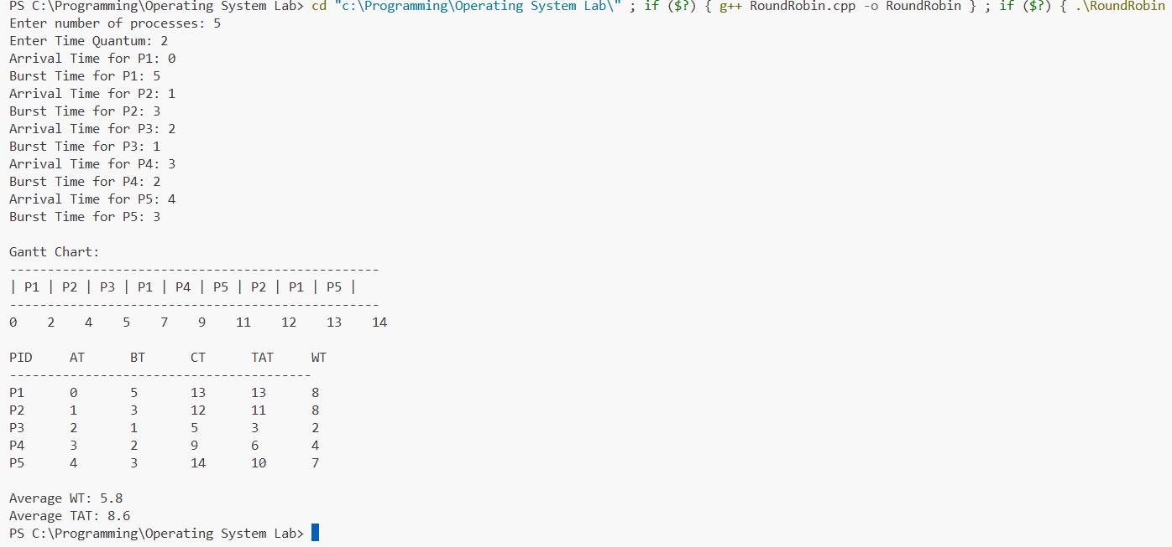

5. Code Explanation (Round Robin CPU Scheduling)
5.1 Header Files
#include <iostream>
#include <vector>
#include <queue>
Explanation:
- iostream → input/output operations
- vector → store process data
- queue → implements Round Robin ready queue

5.2 Process Structure
struct Process {
string pid;
int at, bt, rt, ct, tat, wt;
};
Explanation:
Stores all process details:
- pid → Process ID
- at → Arrival Time
- bt → Burst Time
- rt → Remaining Time (important for RR execution)
- ct → Completion Time
- tat → Turnaround Time
- wt → Waiting Time

5.3 Input Section
for (int i = 0; i < n; i++) {
p[i].pid = "P" + to_string(i + 1);
cin >> p[i].at >> p[i].bt;
p[i].rt = p[i].bt;
}
Explanation:
- Takes arrival and burst time input
- Initializes remaining time = burst time
- Assigns process ID automatically

5.4 Ready Queue Initialization
queue<int> q;
q.push(0);
time = p[0].at;
Explanation:
- Queue stores process indexes
- First arriving process starts execution
- CPU time starts from first process arrival

5.5 Execution Logic (Time Quantum)
int exec = min(tq, p[id].rt);
time += exec;
p[id].rt -= exec;
Explanation:
Process executes for:
- time Quantum OR Remaining Time (whichever is smaller)
- Remaining time decreases after execution

🔷 5.6 Process Completion Handling
if (p[id].rt > 0)
q.push(id);
else
p[id].ct = time;
Explanation:
- If process is not finished → re-add to queue
- If finished → store completion time

🔷 5.7 Adding New Arrivals
if (p[i].at <= time && p[i].rt > 0)
q.push(i);
Explanation:
- Newly arrived processes are added to queue
- Ensures fair CPU sharing

5.8 Gantt Chart Tracking
order.push_back(id);
timeline.push_back(time);
Explanation:
- order → execution sequence
- timeline → time points for Gantt chart

5.9 TAT and WT Calculation
p[i].tat = p[i].ct - p[i].at;
p[i].wt = p[i].tat - p[i].bt;
Explanation:
- Turnaround Time = CT − AT
- Waiting Time = TAT − BT

5.10 Average Calculation
totalWT += p[i].wt;
totalTAT += p[i].tat;
Explanation:
- Computes total waiting and turnaround time
- Used to find averages

7. Discussion
- Simple and easy to implement using a queue structure
- Ensures fairness by giving each process equal CPU time (time quantum)
- Performance depends heavily on the choice of time quantum

6. Conclusion
This project demonstrates how CPU scheduling algorithms affect system performance. SJF provides the best efficiency in terms of waiting time, while Round Robin ensures fairness among all processes. FCFS is the simplest but least efficient in most cases.

Sample Observation
After running the simulation with multiple test cases, the following observations were made:
- FCFS: Simple but leads to higher waiting time if long processes come first.
- SJF: Gives the best average waiting time but may delay longer processes.
- Round Robin: Most fair approach as all processes gets CPU time equally, but context switching increases overhead.

- The complete source code and report of this project is available on GitHub:
- https://github.com/Mdmunnasardar/Operating-System

